**Этапы выполнения работы:**

1. Даталогическая модель данных

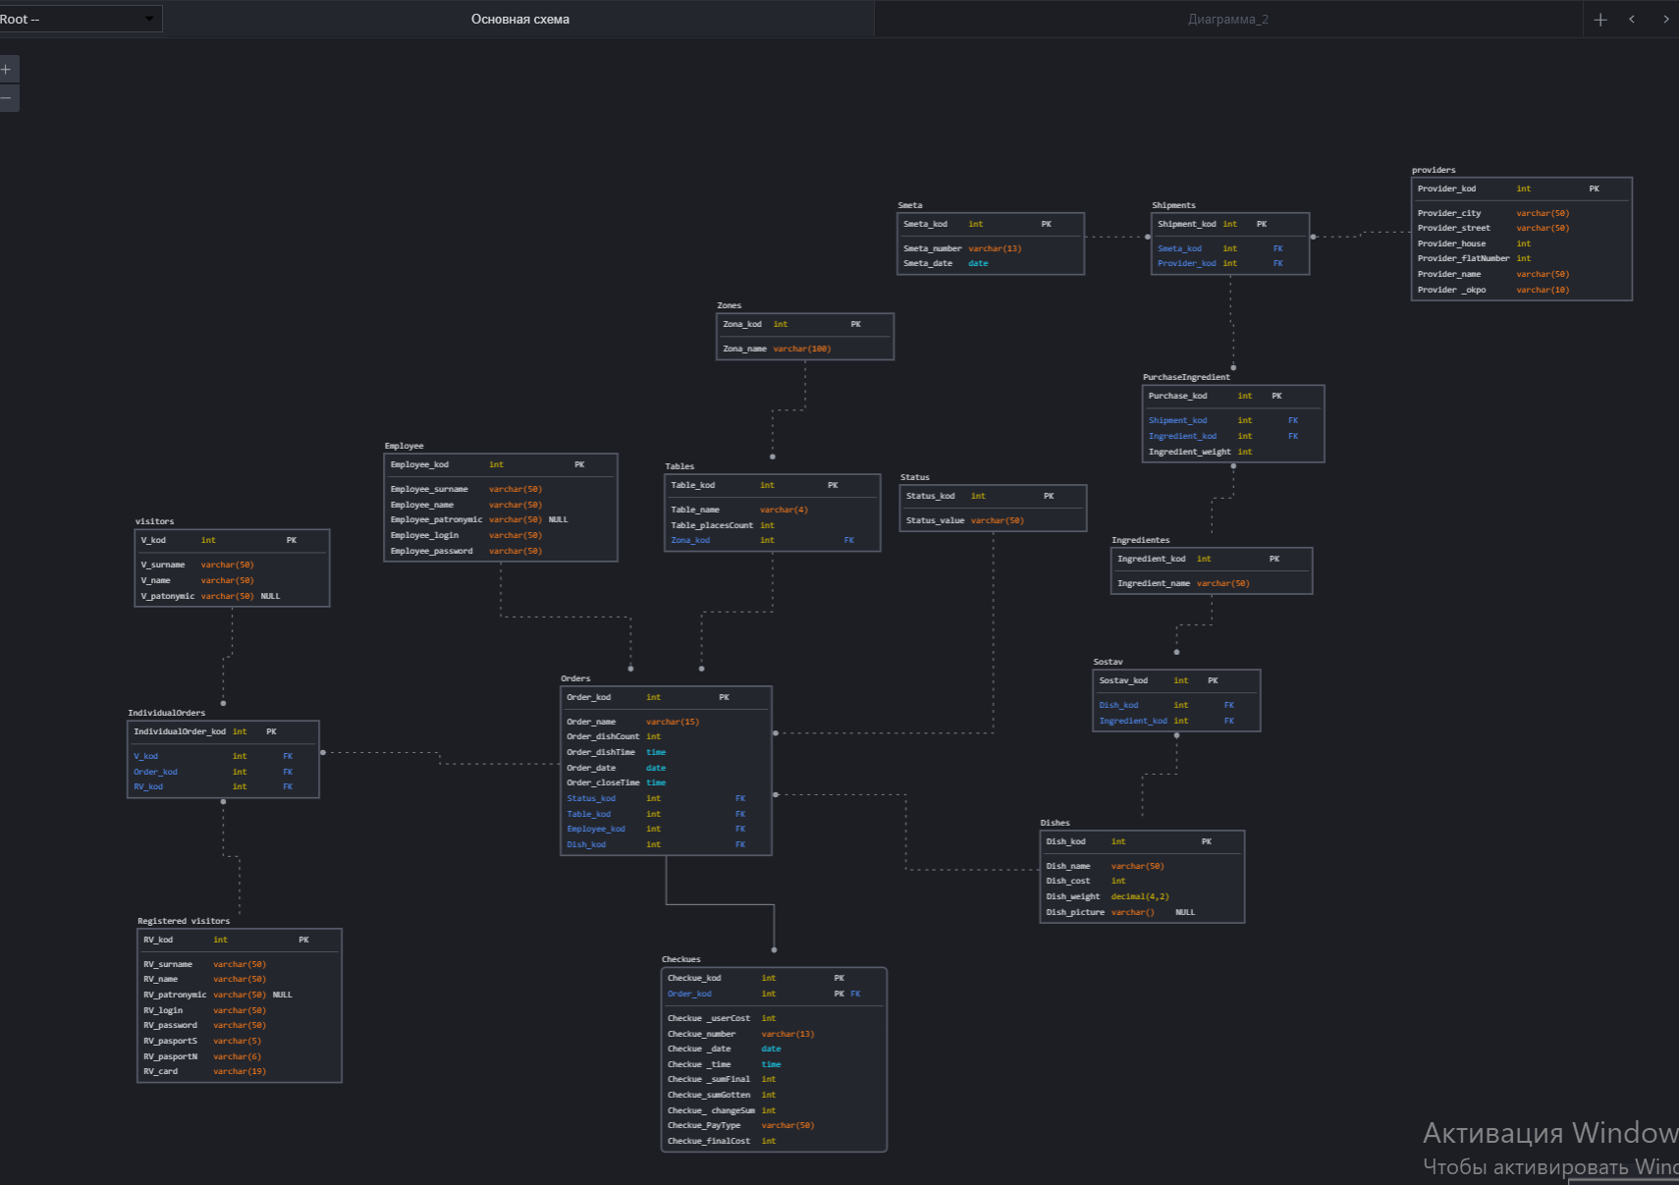

1. Файл скрипта для разработки структуры;
   1. Создание файла;



* 1. Заполнение файла хранимой процедурой для создания таблиц БД.

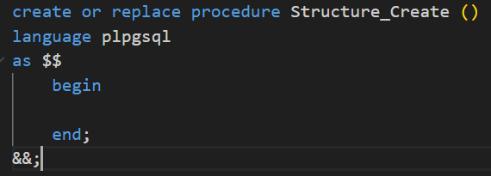

1. Файла скрипта для удаления и перезаписи структуры;
   1. Создание файла;



* 1. Заполнение файла хранимой процедурой для удаления и пересоздания таблиц БД.

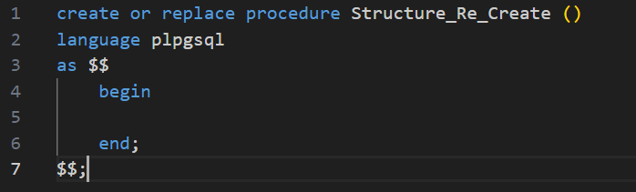

| Название поля | Тип данных | Обязательное | Тип поля | Скрипт | Результат |
| --- | --- | --- | --- | --- | --- |
| Employee | | | | | |
| Employee_surname | Varchar(50) | Да |  | create table if not exists Employee  (  Employee_kod Serial not null constraint PK_Employee primary key,  Employee_surname Varchar(50) not null,  Employee_name Varchar(50) not null,  Employee_patronymic Varchar(50) null,  Employee_login Varchar(50) not null,  Employee_password Varchar(50) not null  ); |  |
| Employee_name | Varchar(50) | Да |  |
| Employee_patronymic | Varchar(50) | нет |  |
| Employee_login | Varchar(50) | Да |  |
| Employee_password | Varchar(50) | Да |  |
| Employee_kod | Int | Да | Суррогатный ключ |
| Registered visitors | | | | | |
| RV_surname | Varchar(50) | Да |  | create table if not exists Registered_Visitors  (  RV_surname Varchar(50) not null,  RV_name Varchar(50) not null,  RV_patronymic Varchar(50) null,  RV_login Varchar(50) not null,  RV_password Varchar(50) not null,  RV_pasportS Varchar(5) not null,  RV_pasportN Varchar(6) not null,  RV_card Varchar(19) not null,  RV_kod Serial not null constraint PK_Registered_Visitors primary key  ); |  |
| RV_name | Varchar(50) | Да |  |
| RV_patronymic | Varchar(50) | Нет |  |
| RV_login | Varchar(50) | Да |  |
| RV_password | Varchar(50) | Да |  |
| RV_pasportS | Varchar(5) | Да |  |
| RV_pasportN | Varchar(6) | Да |  |
| RV_card | Varchar(19) | Да |  |
| RV_kod | Int | Да | Суррогатный ключ |
| visitors | | | | | |
| V_surname | Varchar(50) | Да |  | create table if not exists Visitors  (  V_surname Varchar(50) not null,  V_name Varchar(50) not null,  V_patronymic Varchar(50) null,  V_kod Serial not null constraint PK_Visitors primary key  ); |  |
| V_name | Varchar(50) | Да |  |
| V_patronymic | Varchar(50) | нет |  |
| V_kod | Int | Да | Суррогатный ключ |
| Orders | | | | | |
| Order_name | Varchar(15) | Да |  | create table if not exists Orders  (  Order_name Varchar(15) not null,  Order_dishCount Int not null,  Order_dishTime Time not null,  Order_date Date not null,  Order_closeTime Time not null,  Order_kod Serial not null constraint PK_Orders primary key,  Table_kod Int not null references Wood_tables (Table_kod),  Employee_kod Int not null references Employee (Employee_kod),  Status_kod Int not null references Status (Status_kod)  ); |  |
| Order_dishCount | Int | Да |  |
| Order_dishTime | Time | Да |  |
| Order_date | Date | Да |  |
| Order_closeTime | Time | Да |  |
| Order_kod | Int | Да | Суррогатный ключ |
| Table_kod | Int | Да | Внешний ключ |
| Employee_kod | Int | Да | Внешний ключ |
| Status_kod | Int | Да | Внешний ключ |
| Checkues | | | | | |
| Checkue _userCost | Int | Да |  | create table if not exists Checkues  (  heckue_userCost Int not null,  Checkue_number Varchar(13) not null,  Checkue_date Date not null,  Checkue_time Time not null,  Checkue_sumFinal Int not null,  Checkue_sumGotten Int not null,  Checkue_changeSum Int not null,  Checkue_PayType Varchar(50) not null,  Checkue_finalCost Int not null,  Checkue_kod Serial not null constraint PK_Checkues primary key,  Order_kod Int not null references Orders(Order_kod)  ); |  |
| Checkue_number | Varchar(13) | Да |  |
| Checkue _date | Date | Да |  |
| Checkue _time | Time | Да |  |
| Checkue _sumFinal | Int | Да |  |
| Checkue_sumGotten | Int | Да |  |
| Checkue_ changeSum | Int | Да |  |
| Checkue_PayType | Varchar(50) | Да |  |
| Checkue_finalCost | Int | Да |  |
| Checkue_kod | Int | Да | Суррогатный ключ |
| Order_kod | Int | Да | Внешний ключ |
| Providers | | | | | |
| Provider_city | Varchar(50) | Да |  | create table if not exists Providers  (  Provider_city Varchar(50) not null,  Provider_street Varchar(50) not null,  Provider_house Int not null,  Provider_flatNumber Int not null,  Provider_name Varchar(50) not null,  Provider_okpo Varchar(10) not null,  Provider_kod Serial not null constraint PK_Providers primary key  ); |  |
| Provider_street | Varchar(50) | Да |  |
| Provider_house | Int | Да |  |
| Provider_flatNumber | Int | Да |  |
| Provider_name | Varchar(50) | Да |  |
| Provider _okpo | Varchar(10) | Да |  |
| Provider_kod | Int | Да | Суррогатный ключ |
| Smeta | | | | | |
| Smeta_date | Date | Да |  | create table if not exists Smeta  (  Smeta_date Date not null,  Smeta_number Varchar(13),  Smeta_kod Serial not null constraint PK_Smeta primary key  ); |  |
| Smeta_number | Varchar(13) | Да |  |
| Smeta_kod | Int | Да | Суррогатный ключ |
| Wood_tables | | | | | |
| Table_placesCount | Int | Да |  | create table if not exists Wood_tables  (  Table_placesCount Int not null,  Wood_table_name Varchar(4) not null,  Table_kod Serial not null constraint PK_Wood_Tables primary key,  Zona_kod Int not null references Zones(Zona_kod)  ); |  |
| Wood_table_name | Varchar(4) | Да |  |
| Table_kod | Int | Да | Суррогатный ключ |
| Zona_kod | Int | Да | Внешний ключ |
| Dishes | | | | | |
| Dish_name | Varchar(50) | Да |  | create table if not exists Dishes  (  Dish_name Varchar(50) not null,  Dish_cost Int not null,  Dish_weight Decimal(4,2) not null,  Dish_picture Varchar(1) not null,  Dish_kod Serial not null constraint PK_Dishes primary key  ); |  |
| Dish_cost | Int | Да |  |
| Dish_weight | Decimal(4,2) | Да |  |
| Dish_picture | Varchar() | Да |  |
| Dish_kod | Int | Да | Суррогатный ключ |
| Status | | | | | |
| Status_value | Varchar(50) | Да |  | create table if not exists Status  (  Status_value Varchar(50) not null,  Status_kod Serial not null constraint PK_Status primary key  ); |  |
| Status_kod | Int | Да | Суррогатный ключ |
| Zones | | | | | |
| Zona_name | Varchar(100) | Да |  | create table if not exists Zones  (  Zona_name Varchar(100) not null,  Zona_kod Serial not null constraint PK_Zones primary key  ); |  |
| Zona_kod | Int | Да | Суррогатный ключ |
| Ingredientes | | | | | |
| Ingredient_name | Varchar(50) | Да |  | create table if not exists Ingredientes  (  Ingredient_name Varchar(50) not null,  Ingredient_kod Serial not null constraint PK_Ingredientes primary key  ); |  |
| Ingredient_kod | Int | Да | Суррогатный ключ |
| IndividualOrders | | | | | |
| IndividualOrder_kod | Int | Да | Суррогатный ключ | create table if not exists IndividualOrders  (  IndividualOrder_kod Serial not null constraint PK_IndividualOrders primary key,  Order_kod Int not null references Orders(Order_kod),  V_kod Int not null references Visitors (V_kod),  RV_kod Int not null references Registered_Visitors(RV_kod)  ); |  |
| Order_kod | Int | Да | Внешний ключ |
| V_kod | Int | Да | Внешний ключ |
| RV_kod | Int | Да | Внешний ключ |
| PurchaseIngredient | | | | | |
| Purchase_kod | Int | Да | Суррогатный ключ | create table if not exists PurchaseIngredient  (  Purchase_kod Serial not null constraint PK_PurchaseIngredient primary key,  Ingredient_weight Int not null,  Shipment_kod Int not null references Shipments (Shipment_kod),  Ingredient_kod Int not null references Ingredientes(Ingredient_kod)  ); |  |
| Ingredient_weight | Int | Да |  |
| Shipment_kod | Int | Да | Внешний ключ |
| Ingredient_kod | Int | Да | Внешний ключ |
| Shipments | | | | | |
| Shipment_kod | Int | Да | Суррогатный ключ | create table if not exists Shipments  (  Shipment_kod Serial not null constraint PK_Shipments primary key,  Smeta_kod Int not null references Smeta (Smeta_kod),  Provider_kod Int not null references Providers(Provider_kod)  ); |  |
| Smeta_kod | Int | Да | Внешний ключ |
| Provider_kod | Int | Да | Внешний ключ |
| Sostav | | | | | |
| Sostav_kod | Int | Да | Суррогатный ключ | create table if not exists Sostav  (  Sostav_kod Serial not null constraint PK_Sostav primary key,  Ingredient_kod Int not null references Ingredientes(Ingredient_kod),  Dish_kod Int not null references Dishes(Dish_kod)  ); |  |
| Ingredient_kod | Int | Да | Внешний ключ |
| Dish_kod | Int | Да | Внешний ключ |

* 1. **Скрипт создания индексов.**

| Название поля | Тип поля | Обоснование индекса | Скрипт | | | Результат | |
| --- | --- | --- | --- | --- | --- | --- | --- |
| Employee | | | | | | | | | Varchar(50) | Да |
| Employee_surname |  | Необходим, так как поля уникальны и по данным значениям можно организовать поиск данных | create index if not exists index_fio_employee on employee (employee_name, employee_surname, employee_patronymic); | | |  | |
| Employee_name |  |
| Employee_patronymic |  |
| Employee_login | Унакальное | Необходим, так как позволит быстро произвести аутентификацию пользователя | create index if not exists index_login_password_employee on employee (employee_password, employee_login, employee_patronymic); | | |
| Employee_password |  |
| Employee_kod | Суррогатный ключ | Необходим, так как суррогатный ключ |  | | |
| Registered visitors | | | | | | | | | Varchar(50) | Да |
| RV_surname |  | Необходим, так как поля уникальны и по данным значениям можно организовать поиск данных | create index if not exists index_fio_rv on registered_visitors (rv_name, rv_surname, rvpatronymic); | | |  | |
| RV_name |  |
| RV_patronymic |  |
| RV_login |  | Необходим, так как позволит быстро произвести аутентификацию пользователя | create index if not exists index_login_password_rv on registered_visitors (rv_login, rv_password); | | |
| RV_password |  |
| RV_pasportS |  | Необходим, так как поля уникальны и по данным значениям можно организовать поиск данных | create index if not exists index_pasportSN_rv on registered_visitors (rv_pasportS, rv_pasportN); | | |
| RV_pasportN |  |
| RV_card | Уникальное | Необходим, так как поле уникальное и по данному значению можно организовать поиск данных | create index if not exists index_card_rv on registered_visitors (rv_card); | | |
| RV_kod | Суррогатный ключ | Необходим, так как суррогатный ключ | create index if not exists index_kod_rv on registered_visitors (rv_kod); | | |
| visitors | | | | | | | | | Varchar(50) | Да |
| V_surname |  | Необходим, так как поля уникальны и по данным значениям можно организовать поиск данных | create index if not exists index_fio_visitor on visitors(v_surname, v_name, v_patronymic); | | |  | |
| V_name |  |
| V_patronymic |  |
| V_kod | Суррогатный ключ | Необходим, так как суррогатный ключ | create index if not exists index_kod_visitor on visitors(v_kod); | | |
| Orders | | | | | | | | | Int | Да |
| Order_name | уникальное | Необходим, так как поле уникальное и по данному значению можно организовать поиск данных | create index if not exists index_name_order on orders (order_name); | | |  | |
| Order_dishCount |  |  |  | | |
| Order_dishTime |  | Необходим, так как поля уникальны и по данным значениям можно организовать поиск данных |  | | |
| Order_date |  | create index if not exists index_date_time_order on orders (order_dishtime, order_date, order_closetime); | | |
| Order_closeTime |  |
| Order_kod | Суррогатный ключ | Необходим, так как суррогатный ключ | create index if not exists index_kod_order on orders (order_kod); | | |
| Table_kod | Внешний ключ | Нет необходимости так как, поле внешнего ключа и ключ родительской таблицы уже с индексом |  | | |
| Employee_kod | Внешний ключ | Нет необходимости так как, поле внешнего ключа и ключ родительской таблицы уже с индексом |  | | |
| Status_kod | Внешний ключ | Нет необходимости так как, поле внешнего ключа и ключ родительской таблицы уже с индексом |  | | |
| Checkues | | | | | | | | | Varchar(13) | Да |
| Checkue _userCost |  |  |  | | |  | |
| Checkue_number | Уникальое | Необходим, так как поле уникальное и по данному значению можно организовать поиск данных | create index if not exists index_number_checkue on checkues (checkue_number); | | |
| Checkue _date |  | Необходим, так как поля уникальны и по данным значениям можно организовать поиск данных | create index if not exists index_date_time_checkue on checkues (checkue_date, checkue_time); | | |
| Checkue _time |  |
| Checkue _sumFinal |  |  |  | | |
| Checkue_sumGotten |  |  |  | | |
| Checkue_ changeSum |  |  |  | | |
| Checkue_PayType |  |  |  | | |
| Checkue_finalCost |  |  |  | | |
| Checkue_kod | Суррогатный ключ | Необходим, так как суррогатный ключ | create index if not exists index_kod_checkue on checkues (checkue_kod); | | |
| Order_kod | Внешний ключ | Нет необходимости так как, поле внешнего ключа и ключ родительской таблицы уже с индексом |  | | |
| Providers | | | | | | | | | Varchar(50) | Да |
| Provider_city |  | Необходим, так как поля уникальны и по данным значениям можно организовать поиск данных | create index if not exists index_location_provider on providers (provider_city, provider_street, provider_house, provider_flatnumber); | | |  | |
| Provider_street |  |
| Provider_house |  |
| Provider_flatNumber |  |
| Provider_name | Уникальое | Необходим, так как поле уникальное и по данному значению можно организовать поиск данных | create index if not exists index_name_provider on providers (provider_name); | | |
| Provider _okpo | Уникальое | Необходим, так как поле уникальное и по данному значению можно организовать поиск данных | create index if not exists index_okpo_provider on providers (provider_okpo); | | |
| Provider_kod | Суррогатный ключ | Необходим, так как суррогатный ключ | create index if not exists index_kod_provider on providers (provider_kod); | | |
| Smeta | | | | | | | | | Varchar(13) | Да |
| Smeta_date |  |  |  | | |  | |
| Smeta_number | Уникалькое | Необходим, так как поле уникальное и по данному значению можно организовать поиск данных | create index if not exists index_number_smeta on smeta (smeta_number); | | |
| Smeta_kod | Суррогатный ключ | Необходим, так как суррогатный ключ | create index if not exists index_kod_smeta on smeta (smeta_kod); | | |
| Wood_tables | | | | | | | | | Varchar(4) | Да |
| Table_placesCount |  |  |  | | |  | |
| Wood_table_name | Уникальое | Необходим, так как поле уникальное и по данному значению можно организовать поиск данных | create index if not exists index_name_table on wood_tables(wood_table_name); | | |
| Table_kod | Суррогатный ключ | Необходим, так как суррогатный ключ | create index if not exists index_kod_table on wood_tables (table_kod); | | |
| Zona_kod | Внешний ключ | Нет необходимости так как, поле внешнего ключа и ключ родительской таблицы уже с индексом |  | | |
| Dishes | | | | | | | |
| Dish_name | Уникальое | Необходим, так как поле уникальное и по данному значению можно организовать поиск данных | create index if not exists index_name_dish on dishes(dish_name); | | |  | |
| Dish_cost |  |  |  | | |
| Dish_weight |  |  |  | | |
| Dish_picture |  |  |  | | |
| Dish_kod | Суррогатный ключ | Необходим, так как суррогатный ключ | create index if not exists index_kod_dish on dishes(dish_kod); | | |  | |
| Status | | | | | | | | | Int | Да |
| Status_value | Уникальное | Необходим, так как поле уникальное и по данному значению можно организовать поиск данных | create index if not exists index_value_status on status(status_value); | | |  | |
| Status_kod | Суррогатный ключ | Необходим, так как суррогатный ключ | create index if not exists index_kod_status on status(status_kod); | | |
| Zones | | | | | | | | | Int | Да |
| Zona_name | Уникальное | Необходим, так как поле уникальное и по данному значению можно организовать поиск данных | create index if not exists index_kod_zones on zones(zona_kod); | | |  | |
| Zona_kod | Суррогатный ключ | Необходим, так как суррогатный ключ | create index if not exists index_name_zones on zones(zona_kod); | | |
| Ingredientes | | | | | | | | | Int | Да |
| Ingredient_name | Уникально | Необходим, так как поле уникальное и по данному значению можно организовать поиск данных | create index if not exists index_kod_ingredient on ingredientes(ingredient_kod);  create index if not exists index_name_ingredient on ingredientes(ingredient_name); | | |  | |
| Ingredient_kod | Суррогатный ключ | Необходим, так как суррогатный ключ |
| IndividualOrders | | | | | | | | | Int | Да |
| IndividualOrder_kod | Суррогатный ключ | Необходим, так как суррогатный ключ | create index if not exists index_kod_IndividualOrders on IndividualOrders(IndividualOrder_kod); | | |  | |
| Order_kod | Внешний ключ | Нет необходимости так как, поле внешнего ключа и ключ родительской таблицы уже с индексом |  | | |
| V_kod | Внешний ключ | Нет необходимости так как, поле внешнего ключа и ключ родительской таблицы уже с индексом |  | | |
| RV_kod | Внешний ключ | Нет необходимости так как, поле внешнего ключа и ключ родительской таблицы уже с индексом |  | | |
| PurchaseIngredient | | | | | | | | | Int | Да |
| Purchase_kod | Суррогатный ключ | Необходим, так как суррогатный ключ | create index if not exists index_kod_ PurchaseIngredient on PurchaseIngredient (Purchase_kod); | | |  | |
| Ingredient_weight |  |  |  | | |
| Shipment_kod | Внешний ключ | Нет необходимости так как, поле внешнего ключа и ключ родительской таблицы уже с индексом |  | | |
| Ingredient_kod | Внешний ключ | Нет необходимости так как, поле внешнего ключа и ключ родительской таблицы уже с индексом |  | | |
| Shipments | | | | | | | | | Int | Да |
| Shipment_kod | Суррогатный ключ | Необходим, так как суррогатный ключ | create index if not exists index_kod_Shipments on Shipments(Shipment_kod); | | |  | |
| Smeta_kod | Внешний ключ | Нет необходимости так как, поле внешнего ключа и ключ родительской таблицы уже с индексом |  | | |
| Provider_kod | Внешний ключ | Нет необходимости так как, поле внешнего ключа и ключ родительской таблицы уже с индексом |  | | |
| Sostav | | | | | | | | |  |  |
| Sostav_kod | Суррогатный ключ | Необходим, так как суррогатный ключ | | create index if not exists index_kod_sostav on Sostav(Sostav _kod); |  | |
| Dish_kod | Внешний ключ | Нет необходимости так как, поле внешнего ключа и ключ родительской таблицы уже с индексом | |  |  | |
| Ingredient_kod | Внешний ключ | Нет необходимости так как, поле внешнего ключа и ключ родительской таблицы уже с индексом | |  |

1. Распределение прав доступа к таблицам БД;

Таблица 3 – Права доступа к таблицам БД

| Роли | | официант | Зарегистрированный посетитель | Дополнительный гость | Шеф | Администратор |
| --- | --- | --- | --- | --- | --- | --- |
| Название объекта | Функции |
| Employee | Выборка | X |  |  | X | Х |
| Добавление |  |  |  |  | Х |
| Изменение | X |  |  | X | Х |
| Удаление |  |  |  |  | Х |
| Registered visitors | Выборка |  | Х |  |  | Х |
| Добавление | X |  |  |  | Х |
| Изменение | X | X |  |  | Х |
| Удаление |  |  |  |  | Х |
| visitors | Выборка |  |  | Х |  | X |
| Добавление | X |  |  |  | X |
| Изменение | X |  | X |  | X |
| Удаление |  |  |  |  | X |
| Checkues | Выборка | X | X | X | X | Х |
| Добавление | X |  |  |  |  |
| Изменение | X |  |  |  |  |
| Удаление | X |  |  |  |  |
| Providers | Выборка |  |  |  | X | Х |
| Добавление |  |  |  | X | Х |
| Изменение |  |  |  | X | Х |
| Удаление |  |  |  | X | Х |
| Smeta | Выборка |  |  |  | X | Х |
| Добавление |  |  |  | X | X |
| Изменение |  |  |  | X | X |
| Удаление |  |  |  | X | Х |
| Dishes | Выборка | X | X | X | X |  |
| Добавление |  |  |  | X |  |
| Изменение |  |  |  | X |  |
| Удаление |  |  |  | X |  |
| Zones | Выборка | X | X | X |  | X |
| Добавление |  |  |  |  | X |
| Изменение |  |  |  |  | X |
| Удаление |  |  |  |  | X |
| Ingredientes | Выборка |  |  |  | Х |  |
| Добавление |  |  |  | Х |  |
| Изменение |  |  |  | Х |  |
| Удаление |  |  |  | Х |  |
| IndividualOrders | Выборка | X | Х | Х |  | Х |
| Добавление | X |  |  |  |  |
| Изменение | X |  |  |  |  |
| Удаление | X |  |  |  |  |
| PurchaseIngredient | Выборка |  |  |  | X | Х |
| Добавление |  |  |  | X |  |
| Изменение |  |  |  | X |  |
| Удаление |  |  |  | X |  |
| Shipments | Выборка |  |  |  | X | Х |
| Добавление |  |  |  | X |  |
| Изменение |  |  |  | X |  |
| Удаление |  |  |  | X |  |
| Sostav | Выборка | X | X | X | Х | Х |
| Добавление |  |  |  | Х |  |
| Изменение |  |  |  | Х |  |
| Удаление |  |  |  | X |  |
| orders | Выборка | X | Х | Х | X | Х |
| Добавление | X |  |  |  |  |
| Изменение | X |  |  |  |  |
| Удаление | X |  |  |  |  |

1. Выдача прав доступа к таблицам БД;

Таблица 4 – Реализация разграничения прав доступа

| Название роли | Название объекта | Функция | Скрипт |
| --- | --- | --- | --- |
| res_waiter | Registered visitors | Insert, Update | grant insert, update on Registered_visitors to res_waiter;  grant usage, select on sequence registered_visitors_rv_kod_seq to res_waiter; |
| visitors | grant insert, update on visitors to res_waiter;  grant usage, select on sequence visitors_v_kod_seq to res_waiter; |
| Employee | Select, Update | grant select, update on Employee to res_waiter; |
| zones | Select | grant select on zones to res_waiter; |
| dishes | grant select on dishes to res_waiter; |
| sostav | grant select on sostav to res_waiter; |
| orders | Select, Insert, Update, Delete | grant select, insert, update, delete on orders to res_waiter;  grant usage, select on sequence orders_order_kod_seq to res_waiter; |
| IndividualOrders | grant select, insert, update, delete on IndividualOrders to res_waiter;  grant usage, select on sequence individualorders_individualorder_kod_seq to res_waiter; |
| Checkues | grant select, insert, update, delete on Checkues to res_waiter;  grant usage, select on sequence checkues_checkue_kod_seq to res_waiter; |
| res_guest | Registered_visitors | Select, Update | grant select, update on Registered_visitors to res_guest; |
| orders | Select | grant select on orders to res_guest; |
| IndividualOrders | grant select on IndividualOrders to res_guest; |
| Checkues | grant select on Checkues to res_guest; |
| dishes | grant select on dishes to res_guest; |
| rl_ dguest | visitors | Select, Update | res_dguest |
| orders | Select | grant select on orders to res_dguest; |
| IndividualOrders | grant select on IndividualOrders to res_dguest; |
| Checkues | grant select on Checkues to res_dguest; |
| dishes | grant select on dishes to res_dguest; |
| res_chef | Employee | Select, Update | grant select, update on employee to res_chef; |
| PurchaseIngredient | Select, Insert, Update, Delete | grant select, insert, update, delete on PurchaseIngredient to res_chef;  grant usage, select on sequence purchaseingredient_purchase_kod_seq to res_chef; |
| Shipments | grant select, insert, update, delete on Shipments to res_chef;  grant usage, select on sequence shipments_shipment_kod_seq to res_chef; |
| sostav | grant select, insert, update, delete on sostav to res_chef;  grant usage, select on sequence sostav_sostav_kod_seq to res_chef; |
| Ingredientes | grant select, insert, update, delete on Ingredientes to res_chef;  grant usage, select on sequence ingredientes_ingredient_kod_seq to res_chef; |
| Providers | grant select, insert, update, delete on Providers to res_chef;  grant usage, select on sequence providers_provider_kod_seq to res_chef; |
| Smeta | grant select, insert, update, delete on Smeta to res_chef;  grant usage, select on sequence smeta_smeta_kod_seq to res_chef; |
| Dishes | grant select, insert, update, delete on Dishes to res_chef;  grant usage, select on sequence dishes_dish_kod_seq to res_chef; |
| orders | select | grant select on orders to res_chef; |
| checkues | grant select on checkues to res_chef; |
| res_administrator | Employee | Select, Insert, Update, Delete | grant select, insert, update, delete on Employee to res_chef;  grant usage, select on sequence employee_employee_kod_seq to res_chef; |
| Registered_visitors | grant select, insert, update, delete on Registered_visitors to res_chef;  grant usage, select on sequence registered_visitors_rv_kod_seq to res_chef; |
| visitors | grant select, insert, update, delete on visitors to res_chef;  grant usage, select on sequence visitors_v_kod_seq to res_chef; |
| Providers | grant select, insert, update, delete on Providers to res_chef;  grant usage, select on sequence providers_provider_kod_seq to res_chef; |
| Smeta | grant select, insert, update, delete on Smeta to res_chef;  grant usage, select on sequence smeta_smeta_kod_seq to res_chef; |
| zones | grant select, insert, update, delete on zones to res_chef;  grant usage, select on sequence zones_zona_kod_seq to res_chef; |
| IndividualOrders | select | grant select on IndividualOrders to res_administrator; |
| PurchaseIngredient | grant select on PurchaseIngredient to res_administrator; |
| Shipments | grant select on Shipments to res_administrator; |
| orders | grant select on orders to res_administrator; |

1. Скрипт процедуры на создание таблиц и индексов;

| Скрипт объекта |
| --- |
| create or replace procedure Structure_Create ()  language plpgsql  as $$      begin    create table if not exists Employee  (      Employee_kod Serial not null constraint PK_Employee primary key,      Employee_surname Varchar(50) not null,      Employee_name Varchar(50) not null,      Employee_patronymic Varchar(50) null,      Employee_login Varchar(50) not null,      Employee_password Varchar(50) not null  );  create table if not exists Registered_Visitors  (      RV_surname Varchar(50) not null,      RV_name Varchar(50) not null,      RV_patronymic Varchar(50) null,      RV_login Varchar(50) not null,      RV_password Varchar(50) not null,      RV_pasportS Varchar(5) not null,      RV_pasportN Varchar(6) not null,      RV_card Varchar(19) not null,      RV_kod Serial not null constraint PK_Registered_Visitors primary key  );  create table if not exists Visitors  (      V_surname Varchar(50) not null,      V_name Varchar(50) not null,      V_patronymic Varchar(50) null,      V_kod Serial not null constraint PK_Visitors primary key  );  create table if not exists Providers  (      Provider_city Varchar(50) not null,      Provider_street Varchar(50) not null,      Provider_house Int not null,      Provider_flatNumber Int not null,      Provider_name Varchar(50) not null,      Provider_okpo Varchar(10) not null,      Provider_kod Serial not null constraint PK_Providers primary key  );  create table if not exists Smeta  (      Smeta_date Date not null,      Smeta_number Varchar(13),      Smeta_kod Serial not null constraint PK_Smeta primary key  );  create table if not exists Dishes  (      Dish_name Varchar(50) not null,      Dish_cost Int not null,      Dish_weight Decimal(4,2) not null,      Dish_picture Varchar(1) not null,      Dish_kod Serial not null constraint PK_Dishes primary key  );  create table if not exists Status  (      Status_value Varchar(50) not null,      Status_kod Serial not null constraint PK_Status primary key  );  create table if not exists Zones  (      Zona_name Varchar(100) not null,      Zona_kod Serial not null constraint PK_Zones primary key  );  create table if not exists Ingredientes  (      Ingredient_name Varchar(50) not null,      Ingredient_kod Serial not null constraint PK_Ingredientes primary key  );  create table if not exists Wood_tables  (      Table_placesCount Int not null,      Wood_table_name Varchar(4) not null,      Table_kod Serial not null constraint PK_Wood_Tables primary key,      Zona_kod Int not null references Zones(Zona_kod)  );  create table if not exists Orders  (      Order_name Varchar(15) not null,      Order_dishCount Int not null,      Order_dishTime Time not null,      Order_date Date not null,      Order_closeTime Time not null,      Order_kod Serial not null constraint PK_Orders primary key,      Table_kod Int not null references Wood_tables (Table_kod),      Employee_kod Int not null references Employee (Employee_kod),      Status_kod Int not null references Status (Status_kod)  );  create table if not exists Checkues  (      heckue_userCost Int not null,      Checkue_number Varchar(13) not null,      Checkue_date Date not null,      Checkue_time Time not null,      Checkue_sumFinal Int not null,      Checkue_sumGotten Int not null,      Checkue_changeSum Int not null,      Checkue_PayType Varchar(50) not null,      Checkue_finalCost Int not null,      Checkue_kod Serial not null constraint PK_Checkues primary key,      Order_kod Int not null references Orders(Order_kod)  );  create table if not exists IndividualOrders  (      IndividualOrder_kod Serial not null constraint PK_IndividualOrders primary key,      Order_kod Int not null references Orders(Order_kod),      V_kod Int not null references Visitors (V_kod),      RV_kod Int not null references Registered_Visitors(RV_kod)  );  create table if not exists Shipments  (  Shipment_kod Serial not null constraint PK_Shipments primary key,  Smeta_kod Int not null references Smeta (Smeta_kod),  Provider_kod Int not null references Providers(Provider_kod)  );  create table if not exists PurchaseIngredient  (  Purchase_kod Serial not null constraint PK_PurchaseIngredient primary key,  Ingredient_weight Int not null,  Shipment_kod Int not null references Shipments (Shipment_kod),  Ingredient_kod Int not null references Ingredientes(Ingredient_kod)  );  create table if not exists Sostav  (  Sostav_kod Serial not null constraint PK_Sostav primary key,  Ingredient_kod Int not null references Ingredientes(Ingredient_kod),  Dish_kod Int not null references Dishes(Dish_kod)  );  create index if not exists index_kod_sostav on Sostav(Sostav_kod);  create index if not exists index_kod_Shipments on Shipments(Shipment_kod);  create index if not exists index_kod_PurchaseIngredient on PurchaseIngredient (Purchase_kod);  create index if not exists index_kod_IndividualOrders on IndividualOrders(IndividualOrder_kod);  create index if not exists index_kod_ingredient on ingredientes(ingredient_kod);  create index if not exists index_name_ingredient on ingredientes(ingredient_name);  create index if not exists index_kod_zones on zones(zona_kod);  create index if not exists index_name_zones on zones(zona_kod);  create index if not exists index_kod_status on status(status_kod);  create index if not exists index_name_dish on dishes(dish_name);  create index if not exists index_kod_dish on dishes(dish_kod);  create index if not exists index_name_table on wood_tables(wood_table_name);  create index if not exists index_kod_table on wood_tables (table_kod);  create index if not exists index_number_smeta on smeta (smeta_number);  create index if not exists index_kod_smeta on smeta (smeta_kod);  create index if not exists index_location_provider on providers (provider_city, provider_street, provider_house, provider_flatnumber);  create index if not exists index_name_provider on providers (provider_name);  create index if not exists index_okpo_provider on providers (provider_okpo);  create index if not exists index_kod_provider on providers (provider_kod);  create index if not exists index_number_checkue on checkues (checkue_number);  create index if not exists index_date_time_checkue on checkues (checkue_date, checkue_time);  create index if not exists index_kod_checkue on checkues (checkue_kod);  create index if not exists index_name_order on orders (order_name);  create index if not exists index_date_time_order on orders (order_dishtime, order_date, order_closetime);  create index if not exists index_kod_order on orders (order_kod);  create index if not exists index_fio_visitor on visitors(v_surname, v_name, v_patronymic);  create index if not exists index_kod_visitor on visitors(v_kod);  create index if not exists index_fio_rv on registered_visitors (rv_name, rv_surname, rv_patronymic);  create index if not exists index_login_password_rv on registered_visitors (rv_login, rv_password);  create index if not exists index_pasportSN_rv on registered_visitors (rv_pasportS, rv_pasportN);  create index if not exists index_card_rv on registered_visitors (rv_card);  create index if not exists index_kod_rv on registered_visitors (rv_kod);  create index if not exists index_fio_employee on employee (employee_name, employee_surname, employee_patronymic);  create index if not exists index_login_password_employee on employee (employee_password, employee_login, employee_patronymic);  create index if not exists index_value_status on status(status_value);  grant select on zones to res_waiter;  grant select on dishes to res_waiter;  grant select on sostav to res_waiter;  grant select, update on Employee to res_waiter;  grant select, insert, update, delete on orders to res_waiter;  grant usage, select on sequence orders_order_kod_seq to res_waiter;  grant select, insert, update, delete on IndividualOrders to res_waiter;  grant usage, select on sequence individualorders_individualorder_kod_seq to res_waiter;  grant select, insert, update, delete on Checkues to res_waiter;  grant usage, select on sequence checkues_checkue_kod_seq to res_waiter;  grant insert, update on visitors to res_waiter;  grant usage, select on sequence visitors_v_kod_seq to res_waiter;  grant insert, update on Registered_visitors to res_waiter;  grant usage, select on sequence registered_visitors_rv_kod_seq to res_waiter;    grant select on orders to res_guest;  grant select on IndividualOrders to res_guest;  grant select on Checkues to res_guest;  grant select on dishes to res_guest;  grant select, update on Registered_visitors to res_guest;  grant select on orders to res_dguest;  grant select on IndividualOrders to res_dguest;  grant select on Checkues to res_dguest;  grant select on dishes to res_dguest;  grant select, update on visitors to res_dguest;  grant select on orders to res_chef;  grant select on checkues to res_chef;  grant select, update on visitors to res_dguest;  grant select, insert, update, delete on PurchaseIngredient to res_chef;  grant usage, select on sequence purchaseingredient_purchase_kod_seq to res_chef;  grant select, insert, update, delete on Shipments to res_chef;  grant usage, select on sequence shipments_shipment_kod_seq to res_chef;  grant select, insert, update, delete on sostav to res_chef;  grant usage, select on sequence sostav_sostav_kod_seq to res_chef;  grant select, insert, update, delete on Ingredientes to res_chef;  grant usage, select on sequence ingredientes_ingredient_kod_seq to res_chef;  grant select, insert, update, delete on Providers to res_chef;  grant usage, select on sequence providers_provider_kod_seq to res_chef;  grant select, insert, update, delete on Smeta to res_chef;  grant usage, select on sequence smeta_smeta_kod_seq to res_chef;  grant select, insert, update, delete on Dishes to res_chef;  grant usage, select on sequence dishes_dish_kod_seq to res_chef;  grant select on IndividualOrders to res_administrator;  grant select on PurchaseIngredient to res_administrator;  grant select on Shipments to res_administrator;  grant select on orders to res_administrator;  grant select, insert, update, delete on Registered_visitors to res_administrator;  grant usage, select on sequence registered_visitors_rv_kod_seq to res_administrator;  grant select, insert, update, delete on visitors to res_administrator;  grant usage, select on sequence visitors_v_kod_seq to res_administrator;  grant select, insert, update, delete on Employee to res_administrator;  grant usage, select on sequence employee_employee_kod_seq to res_administrator;  grant select, insert, update, delete on Providers to res_administrator;  grant usage, select on sequence providers_provider_kod_seq to res_administrator;  grant select, insert, update, delete on Smeta to res_administrator;  grant usage, select on sequence smeta_smeta_kod_seq to res_administrator;  grant select, insert, update, delete on zones to res_administrator;  grant usage, select on sequence zones_zona_kod_seq to res_administrator;      end;  &&; |

1. Скрипт процедуры на перезапись структуры БД;

Таблица 6 – Скрипт объекта

| drop or replace procedure Structure_Re_drop ()  language plpgsql  as $$      begin  revoke  usage, select on sequence registered_visitors_rv_kod_seq to res_waiter;  revoke usage, select on sequence orders_order_kod_seq to res_waiter;  revoke usage, select on sequence individualorders_individualorder_kod_seq to res_waiter;  revoke usage, select on sequence checkues_checkue_kod_seq to res_waiter;  revoke usage, select on sequence visitors_v_kod_seq to res_waiter;  revoke usage, select on sequence registered_visitors_rv_kod_seq to res_waiter;  revoke usage, select on sequence dishes_dish_kod_seq to res_chef;  revoke usage, select on sequence purchaseingredient_purchase_kod_seq to res_chef;  revoke usage, select on sequence shipments_shipment_kod_seq to res_chef;  revoke usage, select on sequence visitors_v_kod_seq to res_administrator;  revoke usage, select on sequence registered_visitors_rv_kod_seq to res_administrator;  revoke usage, select on sequence employee_employee_kod_seq to res_administrator;  revoke usage, select on sequence sostav_sostav_kod_seq to res_chef;  revoke usage, select on sequence ingredientes_ingredient_kod_seq to res_chef;  revoke usage, select on sequence providers_provider_kod_seq to res_chef;  revoke usage, select on sequence smeta_smeta_kod_seq to res_chef;  revoke usage, select on sequence dishes_dish_kod_seq to res_chef;  revoke usage, select on sequence providers_provider_kod_seq to res_administrator;  revoke usage, select on sequence zones_zona_kod_seq to res_administrator;  revoke usage, select on sequence smeta_smeta_kod_seq to res_administrator;  revoke select on zones to res_waiter;  revoke select on dishes to res_waiter;  revoke select on sostav to res_waiter;  revoke select, update on Employee to res_waiter;  revoke select, insert, update, delete on orders to res_waiter;  revoke select, insert, update, delete on IndividualOrders to res_waiter;  revoke select, insert, update, delete on Checkues to res_waiter;  revoke insert, update on visitors to res_waiter;  revoke insert, update on Registered_visitors to res_waiter;  revoke select on orders to res_guest;  revoke select on IndividualOrders to res_guest;  revoke select on Checkues to res_guest;  revoke select on dishes to res_guest;  revoke select, update on Registered_visitors to res_guest;  revoke select on orders to res_dguest;  revoke select on IndividualOrders to res_dguest;  revoke select on Checkues to res_dguest;  revoke select on dishes to res_dguest;  revoke select, update on visitors to res_dguest;  revoke select on orders to res_chef;  revoke select on checkues to res_chef;  revoke select, update on visitors to res_dguest;  revoke select, insert, update, delete on PurchaseIngredient to res_chef;  revoke select, insert, update, delete on Shipments to res_chef;  revoke select, insert, update, delete on sostav to res_chef;  revoke select, insert, update, delete on Ingredientes to res_chef;  revoke select, insert, update, delete on Providers to res_chef;  revoke select, insert, update, delete on Smeta to res_chef;  revoke select, insert, update, delete on Dishes to res_chef;  revoke select on IndividualOrders to res_administrator;  revoke select on PurchaseIngredient to res_administrator;  revoke select on Shipments to res_administrator;  revoke select on orders to res_administrator;  revoke select, insert, update, delete on Registered_visitors to res_administrator;  revoke select, insert, update, delete on visitors to res_administrator;  revoke select, insert, update, delete on Employee to res_administrator;  revoke select, insert, update, delete on Providers to res_administrator;  revoke select, insert, update, delete on Smeta to res_administrator;  revoke select, insert, update, delete on zones to res_administrator;  drop index if  exists index_kod_sostav;  drop index if  exists index_kod_Shipments;  drop index if  exists index_kod_PurchaseIngredient;  drop index if  exists index_kod_IndividualOrders;  drop index if  exists index_kod_ingredient;  drop index if  exists index_name_ingredient;  drop index if  exists index_kod_zones;  drop index if  exists index_name_zones;  drop index if  exists index_kod_status;  drop index if  exists index_name_dish;  drop index if  exists index_kod_dish;  drop index if  exists index_name_table;  drop index if  exists index_kod_table;  drop index if  exists index_number_smeta;  drop index if  exists index_kod_smeta;  drop index if  exists index_location_provider;  drop index if  exists index_name_provider;  drop index if  exists index_okpo_provider;  drop index if  exists index_kod_provider;  drop index if  exists index_number_checkue;  drop index if  exists index_date_time_checkue;  drop index if  exists index_kod_checkue;  drop index if  exists index_name_order;  drop index if  exists index_date_time_order;  drop index if  exists index_kod_order;  drop index if  exists index_fio_visitor;  drop index if  exists index_kod_visitor;  drop index if  exists index_fio_rv;  drop index if  exists index_login_password_rv;  drop index if  exists index_pasportSN_rv;  drop index if  exists index_card_rv;  drop index if  exists index_kod_rv;  drop index if  exists index_fio_employee;  drop index if  exists index_login_password_employee;  drop index if  exists index_value_status;  drop table if  exists Employee;  drop table if  exists Registered_Visitors;  drop table if  exists Visitors;  drop table if  exists Providers;  drop table if  exists Smeta;  drop table if  exists Dishes;  drop table if  exists Status;  drop table if  exists Zones;  drop table if  exists Ingredientes;  drop table if  exists Wood_tables;  drop table if  exists Orders;  drop table if  exists Checkues;  drop table if  exists IndividualOrders;  drop table if  exists Shipments;  drop table if exists PurchaseIngredient;  drop table if exists Sostav;  Structure_Create();      end;  $$; |
| --- |
|  |

1. Тестирование доступа к таблицам БД;

Таблица 7 – Доступ ролей к таблицам

| Роль | Локальная БД | | Удалённая БД | |
| --- | --- | --- | --- | --- |
| Есть доступ | Нет доступа | Есть доступ | Нет доступа |
| res_waiter | Запрос: | Запрос: | Запрос: | Запрос: |
| select * from zones; | select * providers; | select * fromorders; | select * from providers; |
| Результат: | Результат: | Результат: | Результат: |
|  |  |  |  |
| res_guest | Запрос: | Запрос: | Запрос: | Запрос: |
| select * from orders; | select * from ingredients; | select * from orders; | select * from providers; |
| Результат: | Результат: | Результат: | Результат: |
|  |  |  |  |
| res_dguest | Запрос: | Запрос: | Запрос: | Запрос: |
| select * from orders; | select * from providers; | select * from visitors; | select * from providers; |
| Результат: | Результат: | Результат: | Результат: |
|  |  |  |  |
| res_chef | Запрос: | Запрос: | Запрос: | Запрос: |
| select * from smeta; | select * from individualorders; | select * from order; | select * from zones; |
| Результат: | Результат: | Результат: | Результат: |
|  |  |  |  |
| res_administrator | Запрос: | Запрос: | Запрос: | Запрос: |
| select * from smeta; | select *from dishes; | select * from smeta; | select *from dishes; |
| Результат: | Результат: | Результат: | Результат: |
|  |  |  |  |

1. Создание резервной копии БД;



1. Версия базы данных

|  | Информация по объектам |
| --- | --- |
| Запрос | select  information_schema.tables.table_name as "Таблицы",  string_agg(distinct information_schema.columns.column_name, ', ') as "Столбцы",  string_agg(distinct pg_indexes.indexname, ', ') as "Индексы"  from information_schema.tables  inner join information_schema.columns  on information_schema.columns.table_name = information_schema.tables.table_name  inner join pg_indexes  on information_schema.tables.table_name = pg_indexes.tablename  where  information_schema.tables.table_schema = 'public' and  indexname not like 'pk_%'  group by  information_schema.tables.table_name  union all  select  (select  count(*)::text  from information_schema.tables  where  table_schema = 'public'),  (select  count(information_schema.columns.column_name)::text  from information_schema.tables  inner join information_schema.columns  on information_schema.columns.table_name = information_schema.tables.table_name  where  information_schema.tables.table_schema = 'public'),  (select  count(pg_indexes.indexname)::text  from information_schema.tables  inner join pg_indexes  on information_schema.tables.table_name = pg_indexes.tablename  where  information_schema.tables.table_schema = 'public' and  indexname not like 'pk_%'); |

Локальная бд

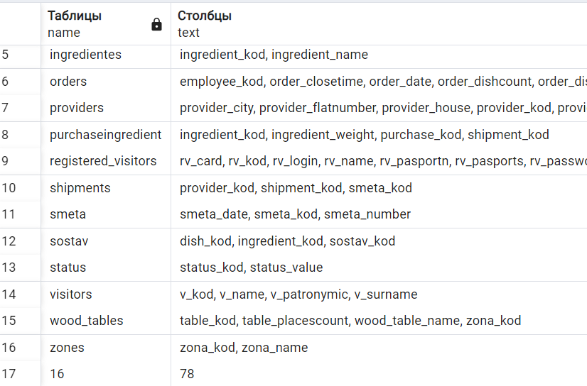

Удаленная бд

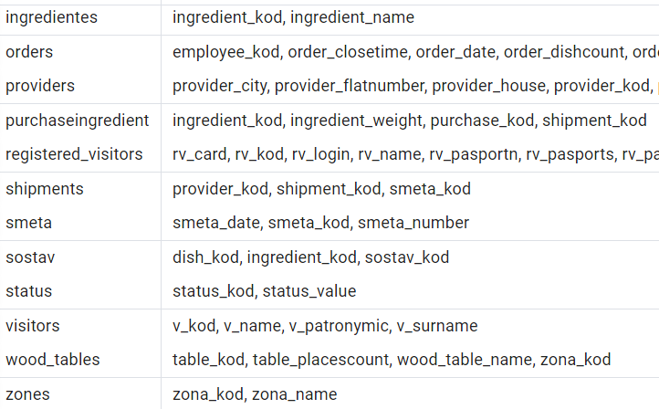

* 1. Версия БД.

Таблица 9 – Версия файла БД

|  |  |
| --- | --- |
| Параметры | PostgreSQL |
| Номер версии | 1.0.0.1 |
| Что сделано | * Созданы 16 таблиц; * Созданы 58 столбцов и межтабличные связи; * Созданы 35 индекса; * Произведено распределение доступа ролей к таблицам; * Созданы процедуры, для быстрого создания и перезаписи всей структуры таблиц, индексов и прав доступа; * Создан Backup файл. |